Weird and Wonderful Vegetables from Gibside Community Farm 2020 - 2021
Growing organic veg means that we buy organic seeds. This gives us a range of veg varieties that are sometimes more unusual than you find in the supermarket. We hope that you will find them more tasty and good to try for a change.
Below is a list of veg and the varieties that we are growing this year, what some of their characteristics are and how you might prepare and cook them.
Veg | Variety | What they look like | Cooking characteristics?
Runner Beans | Enorma  A heavy cropper with long smooth pods and scarlet flowers. | 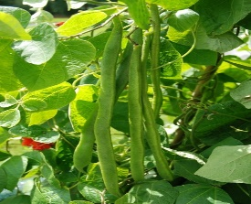 | Top and tail the beans and remove the seams of the pods on both long sides with a sharp knife, then cut into your preferred shape.  We like to boil runner beans in a little salted water to really bring out their flavour. They can also be steamed
French beans climbing | Blauhilde  Purple beans turn green after cooking | 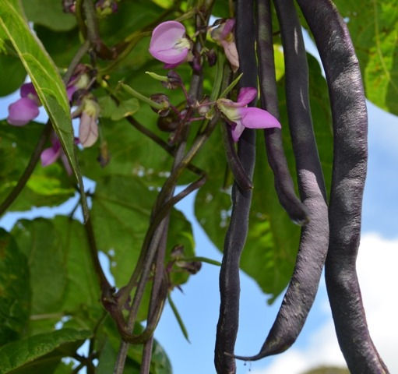 | The simplest way to enjoy your French beans fresh from the garden is to steam them until just tender.  They are also essential in a Minestrone soup and Niçoise salad or baked in the oven with onions and tomatoes in a Greek style
French beans climbing | Cobra  High yielding easy to grow climbing french bean with round pods of excellent flavour | 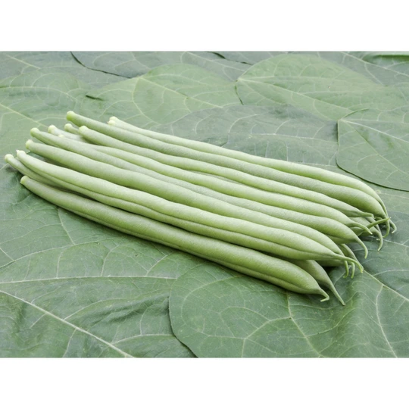 | As above
French beans dwarf | Maxi | 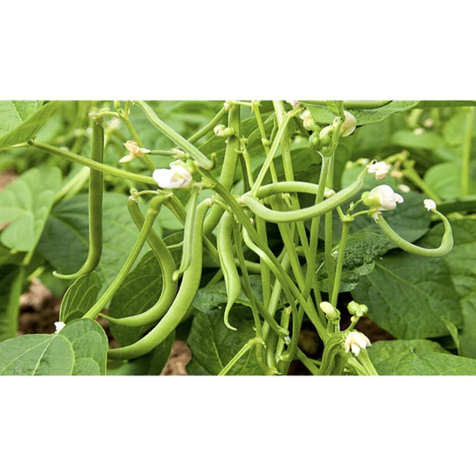 | As above
Beetroot | Alvro Mono  Very early mono-germ type giving round, smooth roots. Can be pickled whole when young | 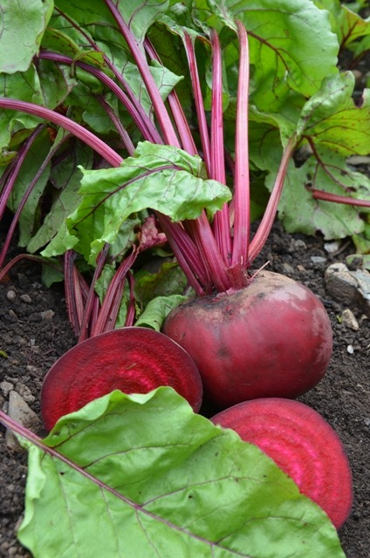 | Beetroot can be washed, peeled and grated for salads. It is also an essential ingredient of Borscht. Leaves can be eaten as leaf beat.  Twist or cut the leaves down to about 5 cm. We like to wash but not peel (this prevents staining), then boil for 40 minutes plus depending on size.  They can also be baked in foil in the oven at 150 °C (gas mark 2) for 2 or 3 hours
Beetroot | Cylindra  Long rooted type with very good flavour. Perfect for slicing and stores well. | 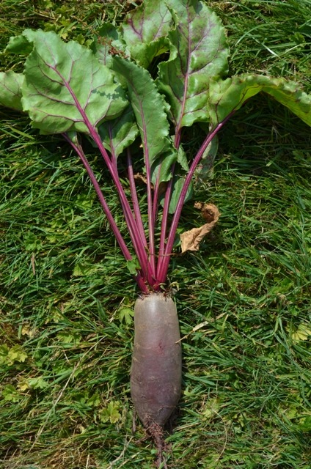 | Cook and use as above
Beetroot | Chiogga  Italian beet with pink skin and white flesh with attractive pink rings. Sweet taste. | 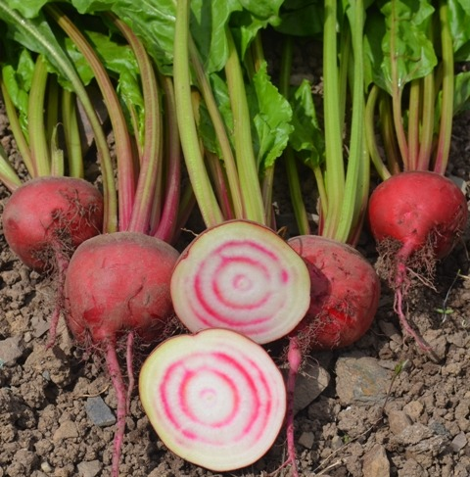 | Cook and use as above
Beetroot | Jannis  it is a reliable performer and gives roots of excellent taste and texture. | 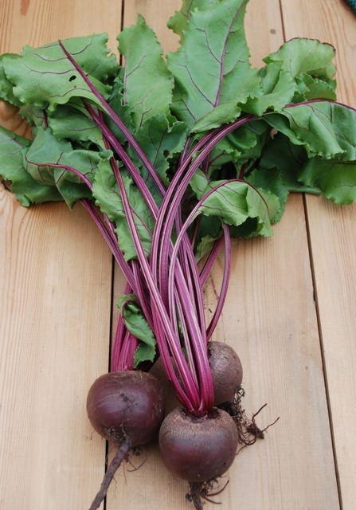 | Cook and use as above
Broad Bean | Ratio & Wizard | 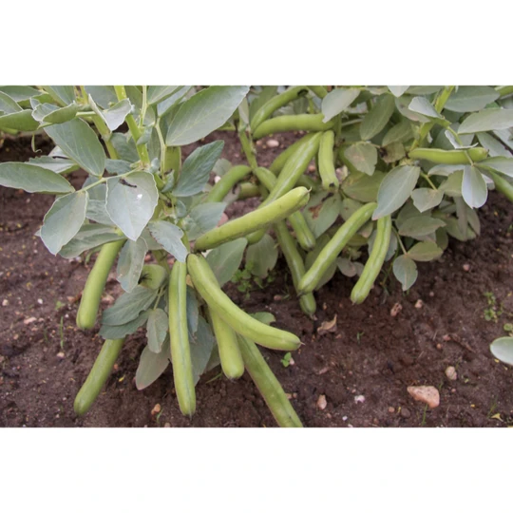 | Boil, steam, blanch. Serve these tasty legumes in fresh salads, meat dishes, casseroles and more. Blanch and remove outer casing of bean (which can get tough) as the season progresses.
Broccoli  Purple Sprouting | Purple sprouting late  succulent purple spears | 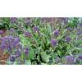 | Steam or stir fry 2-6 mins
Brussel sprouts | Groniger  Greyish green colour  Great, sweet tasting Brussels sprout | 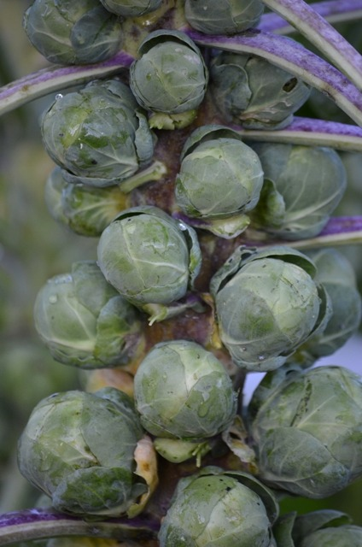 | Steam or fry. Sprouts can be shredded and make a perfect accompanying vegetable, but are also excellent steamed and then fried with butter and chestnuts.  Cut the stem at the base of the sprout. Remove the very outer leaves to reveal a clean firm button.  Some chefs like to put a cross in the base with a sharp knife to help the sprout cook evenly if they are quite large, otherwise just steam until tender being careful not to overcook
Brussel sprouts | Doric F1  favourite Brussels Sprout, not least because it is at its best around Christmas time and it gives tight round buttons of fine flavour | 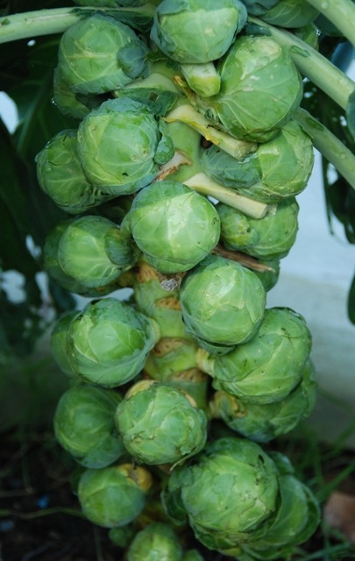 | Steam, fry, cook and use as above
Brussel Sprout Tops | All varieties | 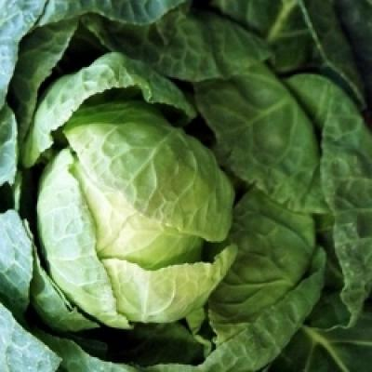 | The very top of the Brussel sprout plant. It has a very sweet cabbage taste. Use in all the many ways you would a cabbage. Cut in half and steam, boil, braise or stir fry.
Cabbage | Drago F1  green, ball-head cabbage | 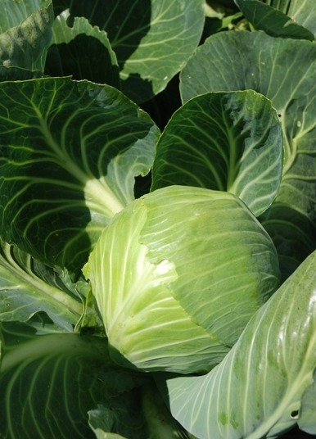 | Steam, boil, fry, soups, coleslaw, ferment, stir fry  Steam or boil in a little water until tender. Do not overcook. Cabbages are great in stir fry, soup, stews, and with potatoes in Irish Colcannon. Leaves can be stuffed or grated for salads like coleslaw
Cabbage savoy | Ormskirk  Light green heads with blistered texture to leaves | 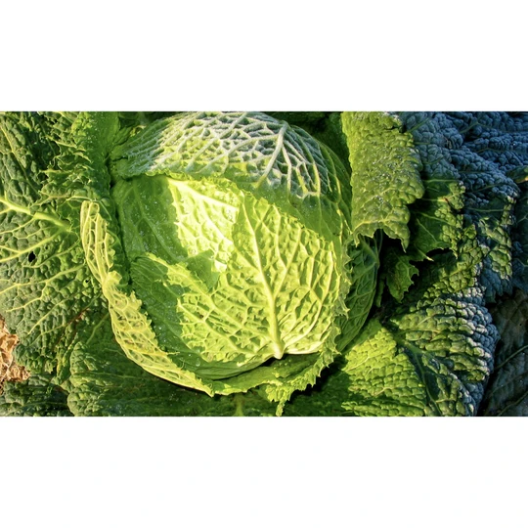 | Steam, boil, fry, soups, ferment, stir fry
Cabbage savoy | Paresa  dark green flattish round heads, blistered texture to leaves | 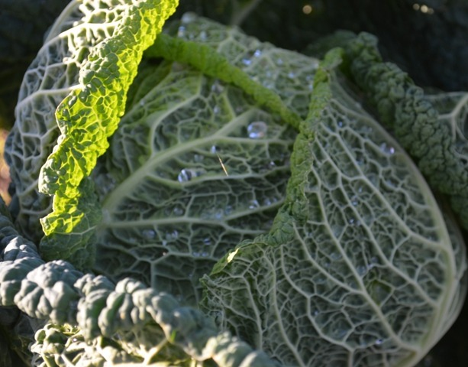 | Steam, boil fry, soups, ferment, stir fry
Cabbage Red | RED RODYNDA | 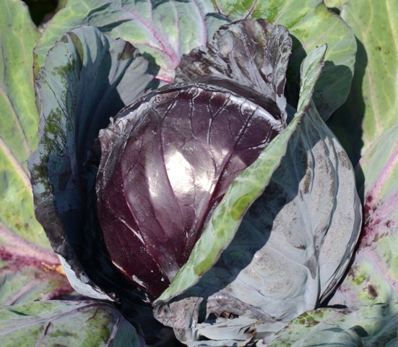 | Cut cabbages as required. Remove the outer leaves and compost them. Cut the cabbage in half and then shred to the desired thickness.  Steam or boil in a little boiling water until tender. Do not overcook. Cabbages are great in stir fry, soup and stews, with potatoes in Irish Colcannon, leaves can be stuffed or  grated for salads like coleslaw.
Cabbage Red | RED LANGEDIJKER BEWAAR 2 | 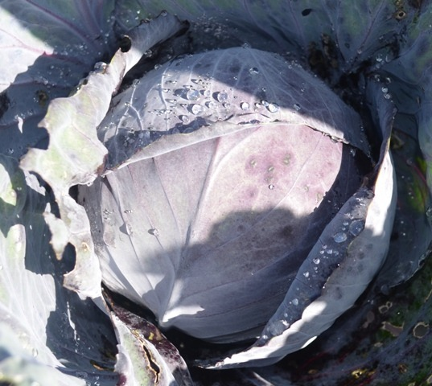 | As above
Calabrese | Belstar | 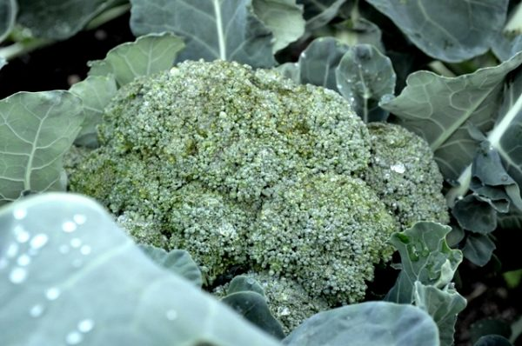 | Calabrese are best lightly steamed or stir fried. It is also good in pasta, with a cheese sauce, in a vegetable crumble or steamed and served cold in a tamari and lemon juice dressing
Carrot | Rodeliker | 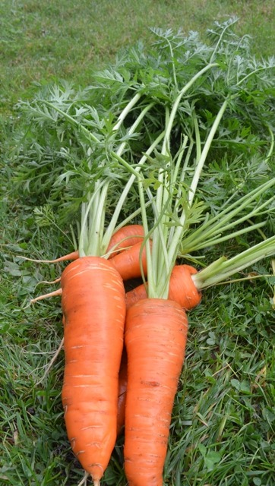 | Carrots are best cut into chunks, rounds, or strips, and steamed until tender. They can be stir fried, sautéed, or roasted. They are also a valuable ingredient in soups and stews.  We love eating them raw for dips or grated in salads.
Cauliflower | Medallion  White “curds” in Feb/March | 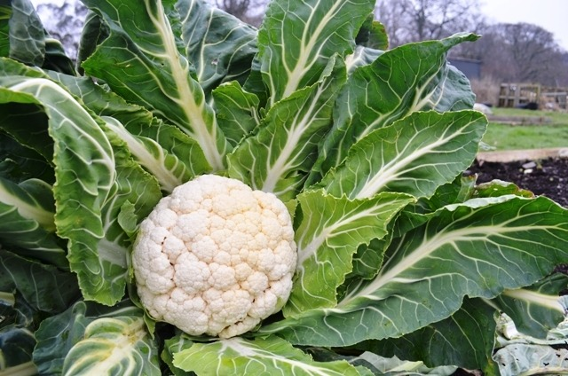 | Steam, curry, with cheese  Simply steam Cauliflower as a vegetable accompaniment. They are also great in curry, in Cauliflower Cheese, and it is also an essential ingredient of Piccalilli
Chard | 5 colours | 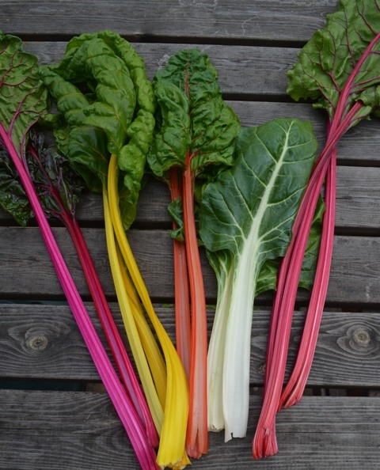 | mix of red, purple/pink, orange, yellow and white coloured stems and leaves. great in tarts and pies, quiche, patties and curry, stir fries.
Chard | Rhubarb | 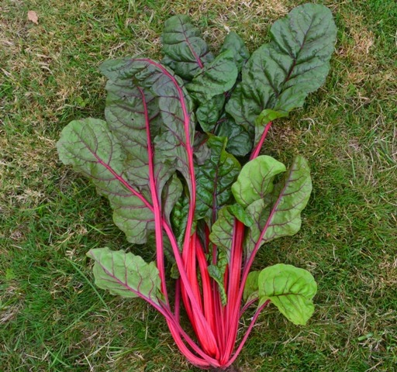 | Striking variety with tasty red/green leaves and bright red stem and ribs: great in tarts and pies, quiche, patties and curry
Courgette | Keesha | 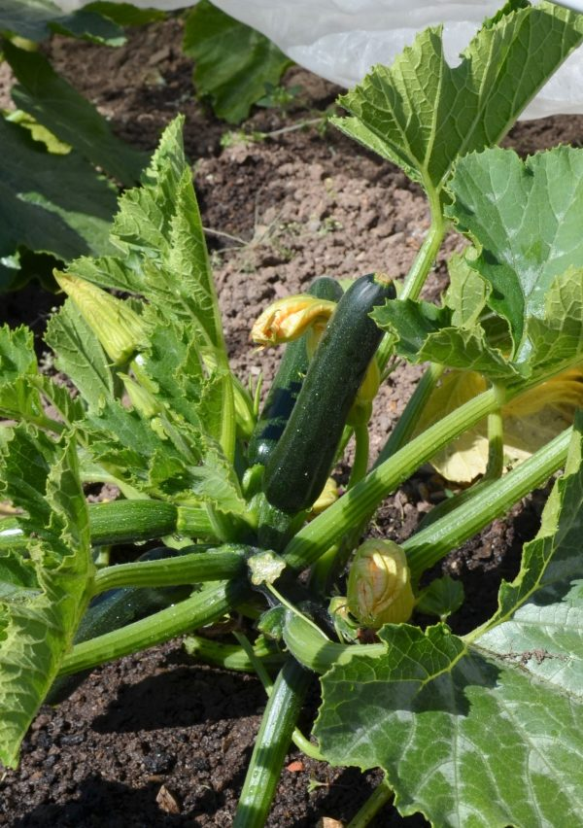 | Slice to the desired shape and steam or fry as an accompanying vegetable, tempura small, young courgettes with their flowers on if very fresh. Courgettes are ideal in stir fry, stew, lasagne, quiche  and vegetable crumble or made into gratin with tomatoes. They can be sliced and griddled with olive oil or grated and make into fritters.
Courgette | Zelia F1 | 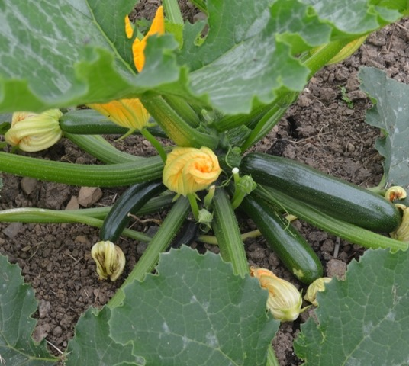 | As above
Endive | Escariol Green | 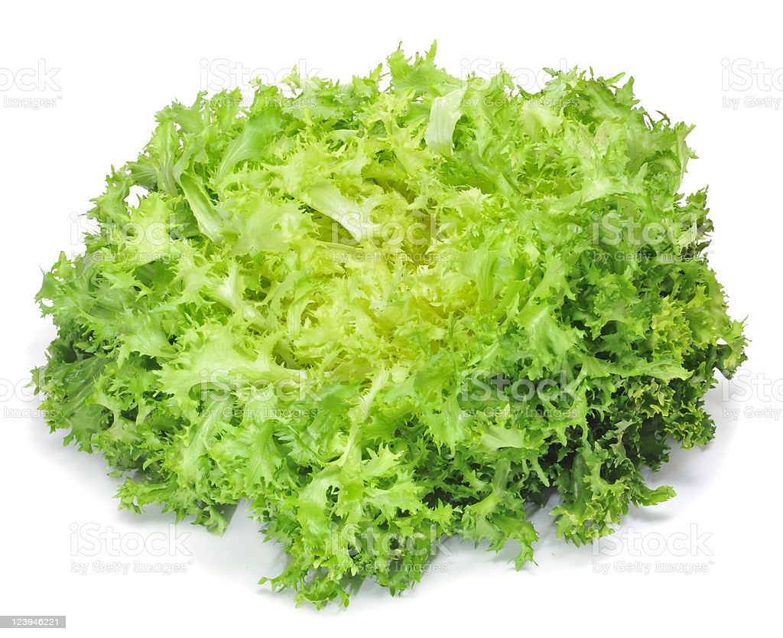 | Broad leaf type. Can be bitter, good in salads with walnut, blue cheese, lemon juice, can also be cooked
Fennel | FLORENCE FENNEL: Fino | 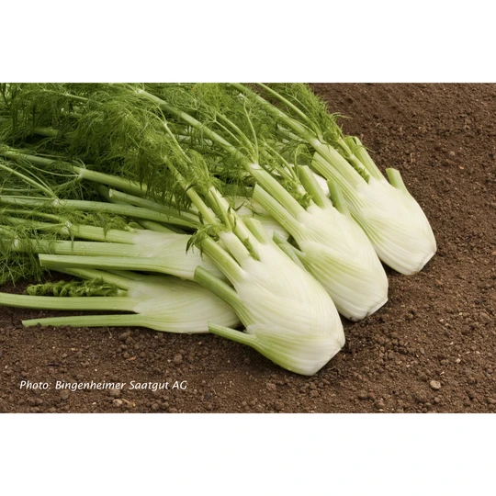 | Fennel gives a sweet liquorice-like taste and scent to curries, stews, bread, desserts, and beverages. Roast to eat with fish.  In some parts of the world, people chew plain or sugar-coated fennel seeds after a meal. Chewing fennel seeds is thought to help aid digestion and prevent gas.
Garlic | Messidor | 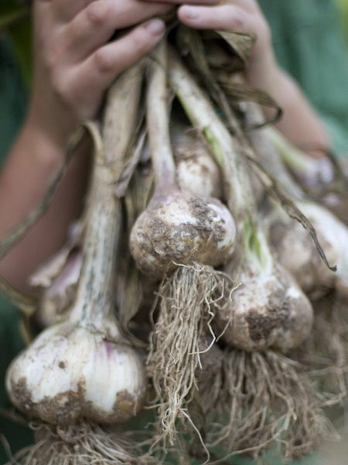 | White, soft neck. Put in wide range of dishes, milder when cooked
Jerusalem Artichoke | Fuseau | 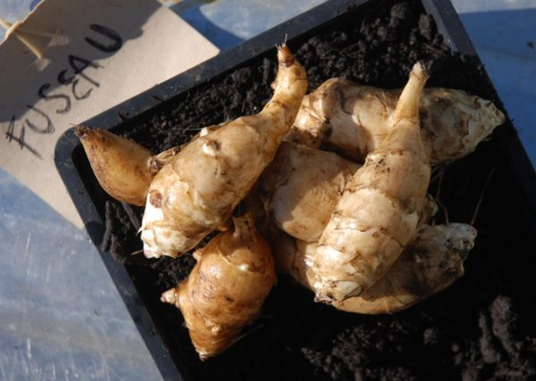 | White skinned. Nutty crunchy veg very good in soups, can be steamed or roasted, best to eat a little to start with to help your stomach get used to it, as it can have a flatulence effect
Jerusalem Artichoke | Gerard | 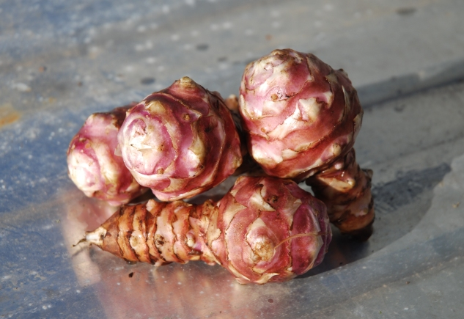 | Red skinned. Nutty crunchy veg very good in soups, can be steamed or roasted, best to eat a little to start with to help your stomach get used to it, as it can have a flatulence effect
Kale | Halbhoher grun krauser | 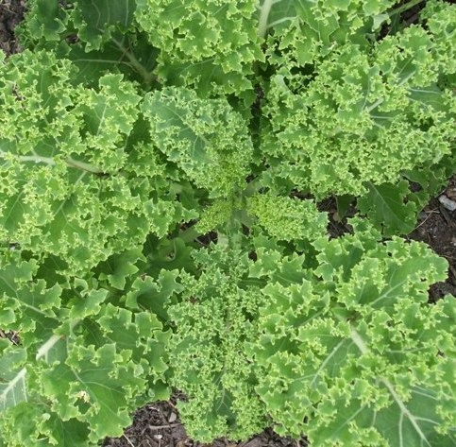 | Dark-green, deeply-curled leaves. Steam
Kale | Red Russian | 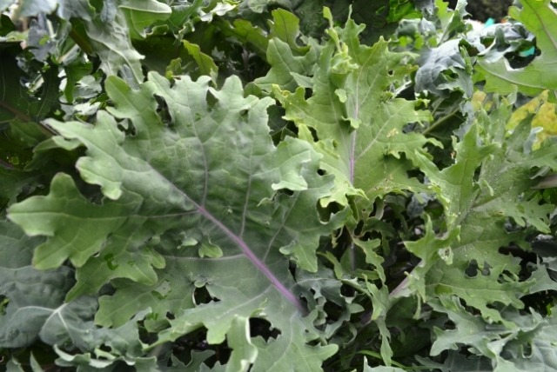 | Blue-green wavy leaf with a red-purple stem and vein
Kale | Red Curled | 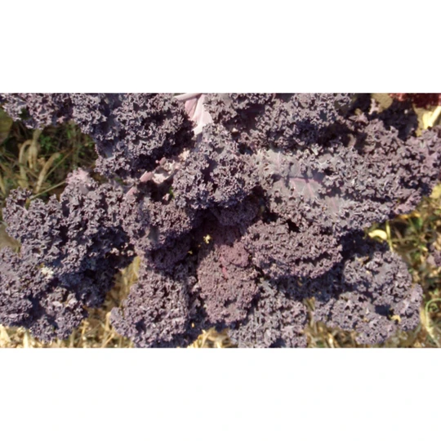 | A red leaved variety high in vitamins. The taste improves after frost. Boil, steam, stir fry.
Kale | Nero di Toscana or Cavolo Nero | 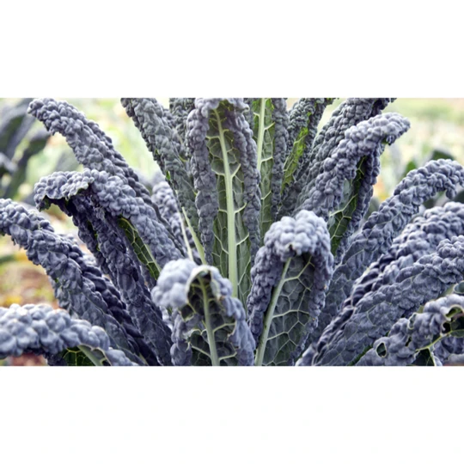 | These strong plants produce long, thin, dark crinkled leaves for winter picking. Boiling, steaming, stir fry.
Land Cress | Land cress | 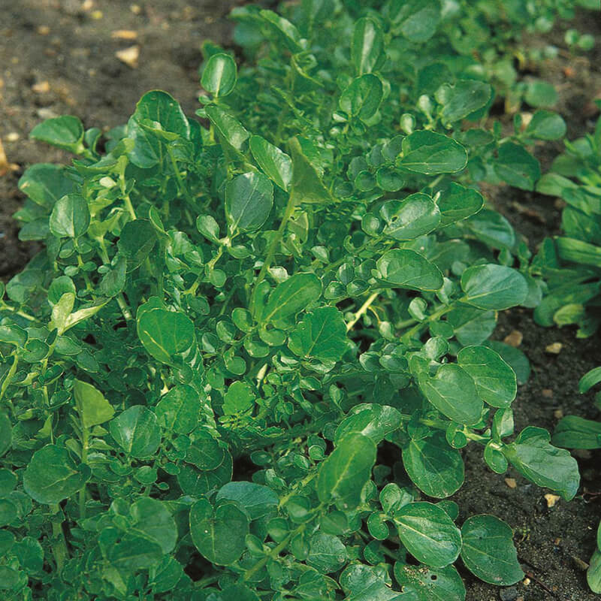 | Green leaf. Strong spicy flavour, put in salads
Leeks | Hannibal | 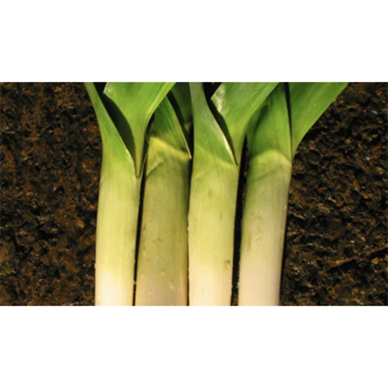 | Cut the root off and the tough outer green leaves. Leeks need a good clean as they can sometimes be a bit gritty. You can slice them in half lengthways and rinse them or cut them into discs rinsing between the rounds if you find a bit of dirt.  Leeks can be sautéed or roasted. Great in stews, they make the perfect soup with potatoes, or side vegetable in a white sauce. Roast, stew, soup, Boil, steam, stir fry, pasties.
Leeks | Blue green winter avano | 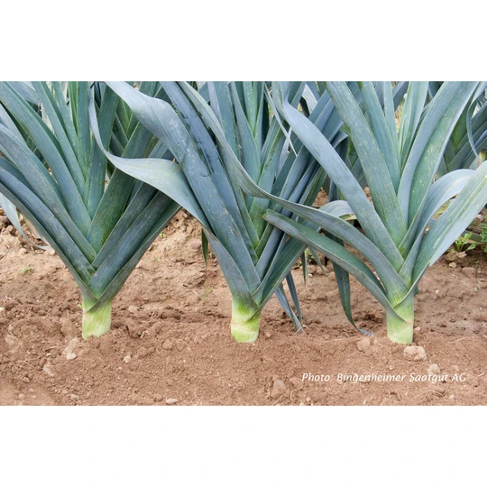 | Long shafts and erect dark green foliage. As above. Roast, stew, soup, Boil, steam, stir fry, pasties.
Leeks | Bandit | 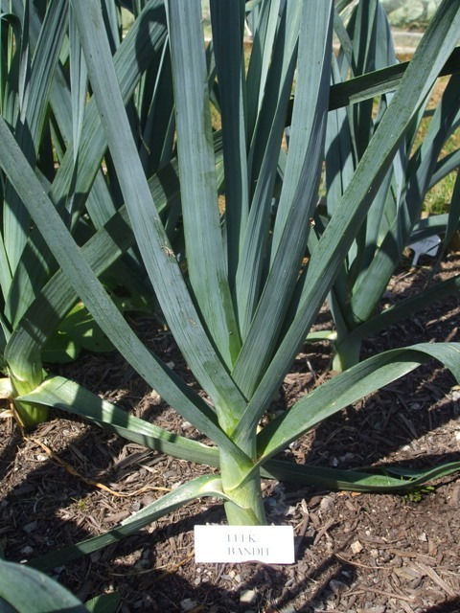 | Heavy yielding and uniform variety with long shanks and blue-green, upright foliage. As above. Leeks can be sautéed or roasted. Great in stews, they make the perfect soup with potatoes, or side vegetable in a white sauce.
Leeks | Husky | 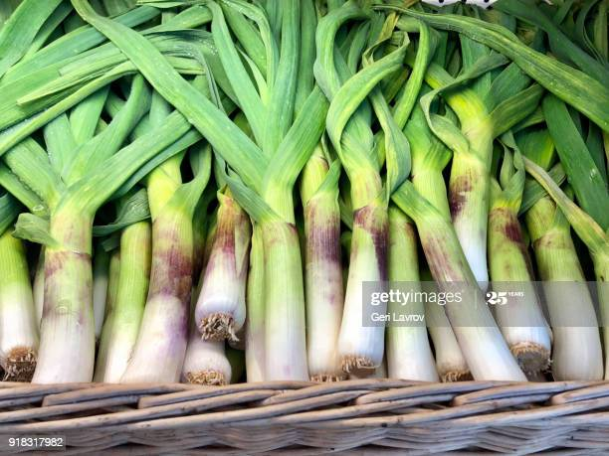 | The long white shaft continues to grow into the depths of winter. As above
Lettuce | Lollo Rossa | 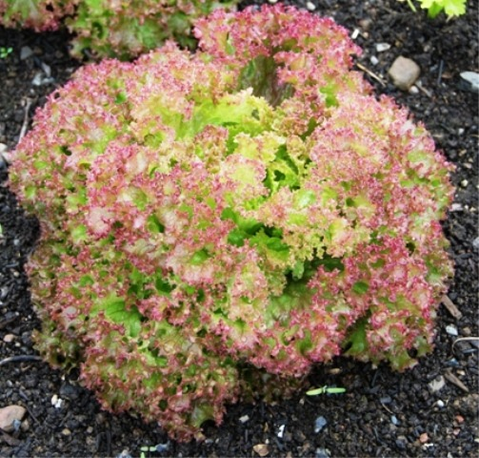 | Lettuce can be braised and even cooked in soup but it is primarily a salad plant. It is not just to be thrown together with a bit of cucumber and tomato though as there are many other uses.  It’s great in burger buns, sandwiches, spicy wraps and even as a bed for a tikka curry. We like to wash lettuce and dry it in a clean tea towel or you can use a salad spinner.  Mix with other leafy greens like cress, rocket or corn salad for a perfect green salad
Lettuce | Red Salad Bowl  Red oak leaf lettuce forms a dense bunch of leaves. For spring to autumn cultivation | 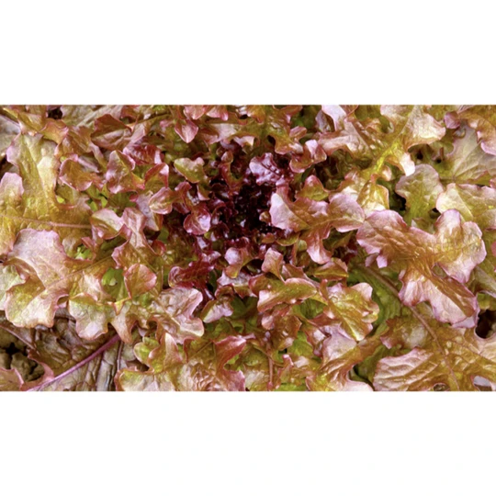 | As above
Lettuce | Valamine  Forms upright heads with long dark green crisp leaves | 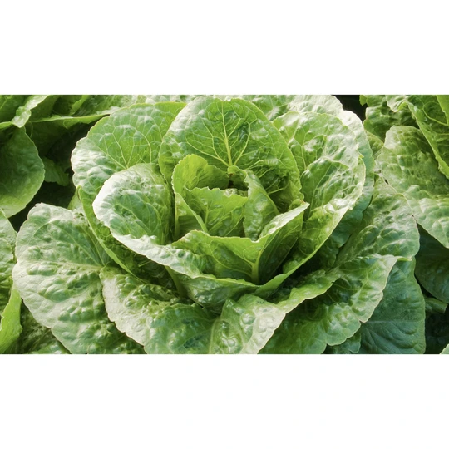 | As above
Onions  Over winter Onions | Troy | 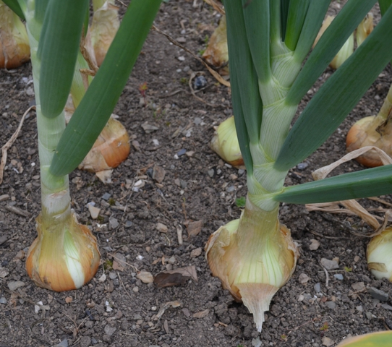 | Onions are used extensively as the starting point for so many dishes. Cut off the top and peel away the papery skin. Chop or slice and remove the root end. This is where they eye watering oil is concentrated. Fry gently in oil or butter for a good ten minutes to cook through and bring out the sweetness and away you go with your dishes. Onions can be roasted and pair extremely well with thyme. They can be eaten raw in salads and salsa, or made into pickles and chutneys
Onions | Centurion | 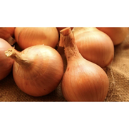 | As above
Onions | Red onions: Robelija | 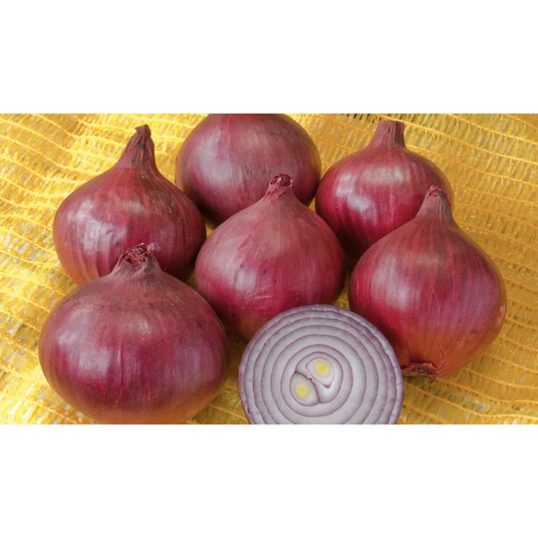 | They're best raw in salads, salsas, and as a topping on burgers and sandwiches because of how mild they are. They can be used in cooked dishes as well, but the onion flavour isn't nearly as strong when they're cooked. Often used in chutneys and relishes.
Parsnip | Halblange White | 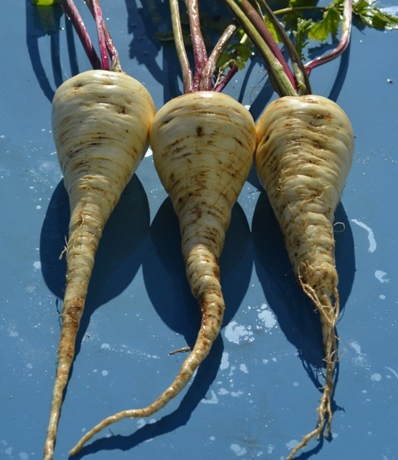 | Cut off the leafy top and wash away the dirt, young roots can just be scrubbed clean while older ones will need to be peeled. Chop and boil to mash as a puree or cut into the desired shape and roast.  Parsnips make excellent croquettes, they go well in curry, soups and stews and can even be used like carrot in cakes.
Peas  mangetout | Sugar dwarf sweet green | 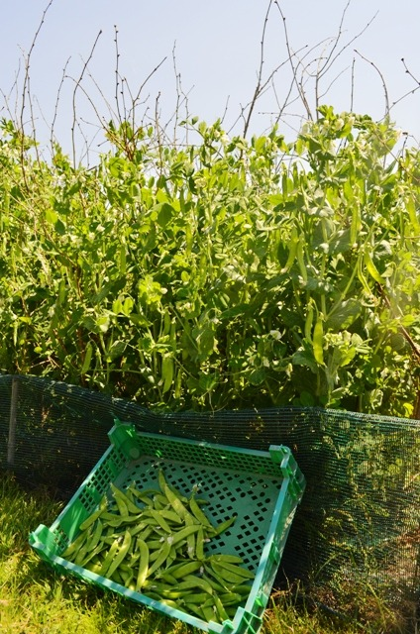 | If you haven’t eaten them all by the time you get to the kitchen pop podded peas into a small amount of boiling water, no salt, for a minute or two only. Mange tout are best steamed, again for just a couple of minutes.  Peas are also fantastic in dishes like risotto, pilaf and pasta. They can also be pureed or go in salad and soup; they are especially good paired with mint
Peas  Sugar snap | Nairobi | 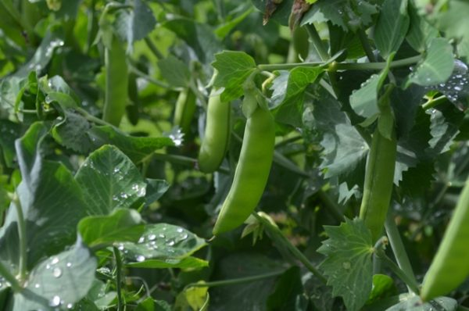 | As above
Potato | Alouette  Long oval with shallow eyes, red skin and yellow flesh colour. | 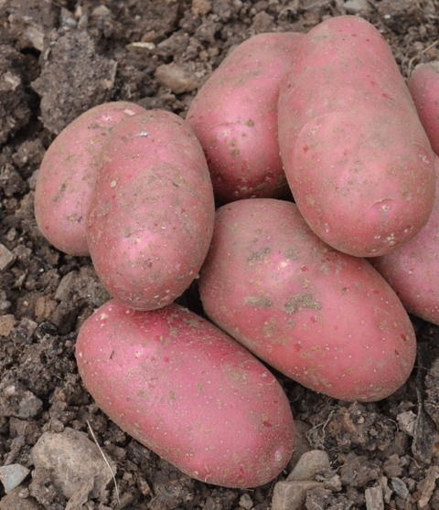 | Baking boiling, chips roast
Potato | Kestrel  Long oval with purple eyes, white flesh | 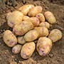 | Good all-rounder, good chipper
Potato | Kifli  Long tuber with medium deep eyes, creamy flesh | 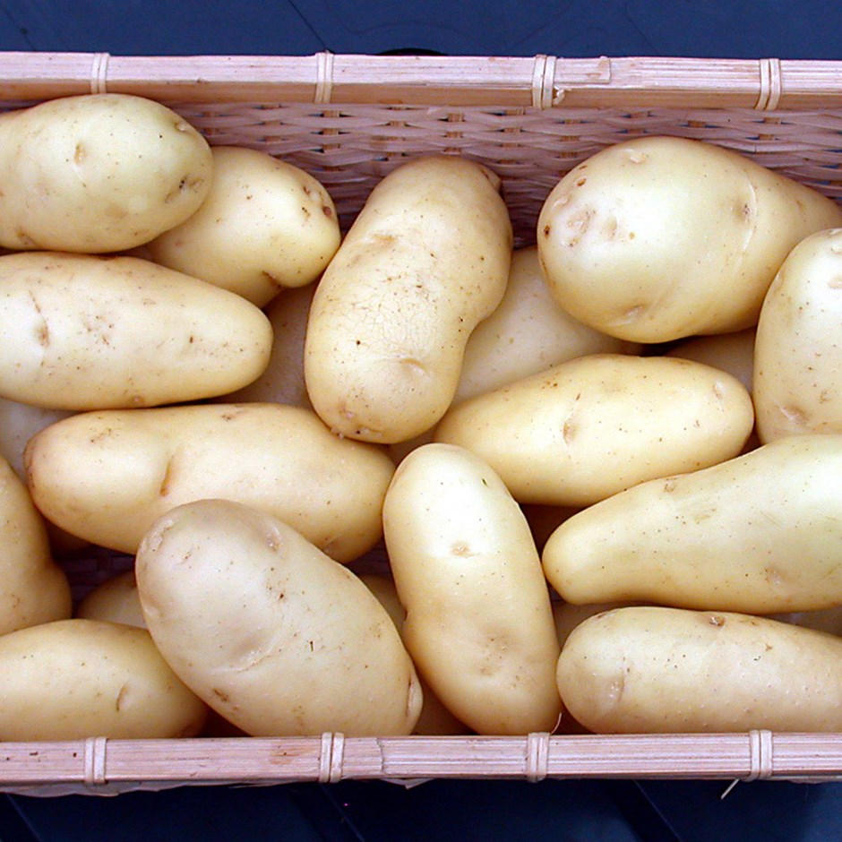 | Waxy potato, great for salads and boiling
Potato | Una | 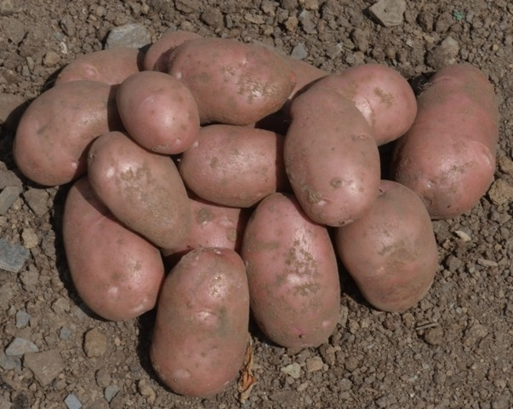 | Red skin white flesh. Baking
Potato  Heritage | Heidi Red  German Speciality potato | 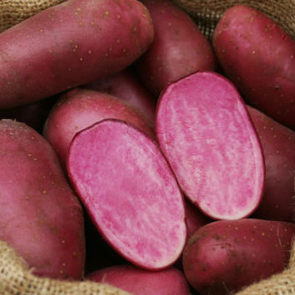 | Long shaped tubers with bright red skin and flesh. Salads and boiling
Potato  Heritage | Violetta  Heritage potato | 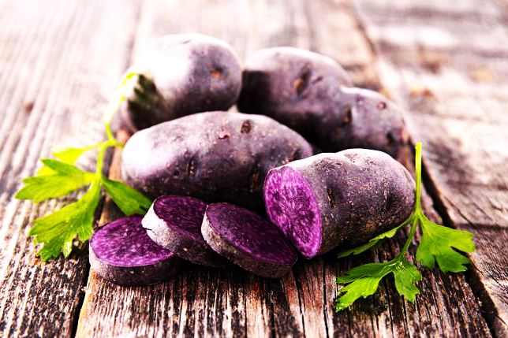 | Blue skin and blue flesh delicate sweet flavour, a slightly fluffy flesh, to keep the colour keep the skin on
Potato  Heritage | Mayan Twilight | 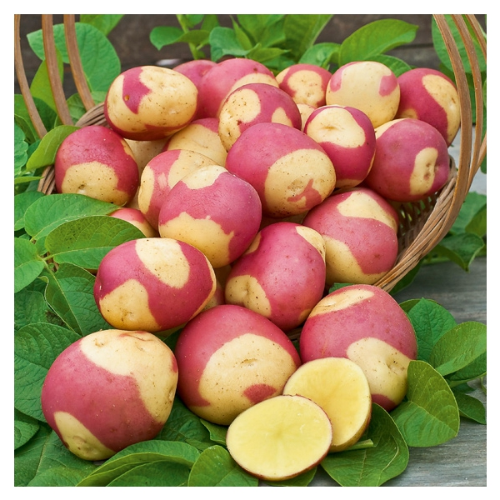 | Red parti-coloured skin and creamy, golden flesh. Salad, roasting, baking
Potato  Heritage | Red Emmalie | 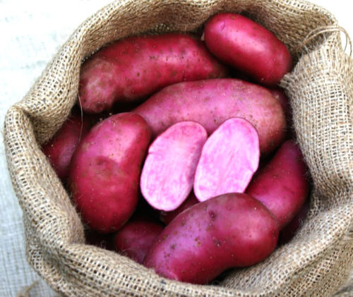 | Red skin and red flesh, long tubers, slightly lighter red than Heidi Red! Mashing and boiling
Potato  Heritage | Anya | 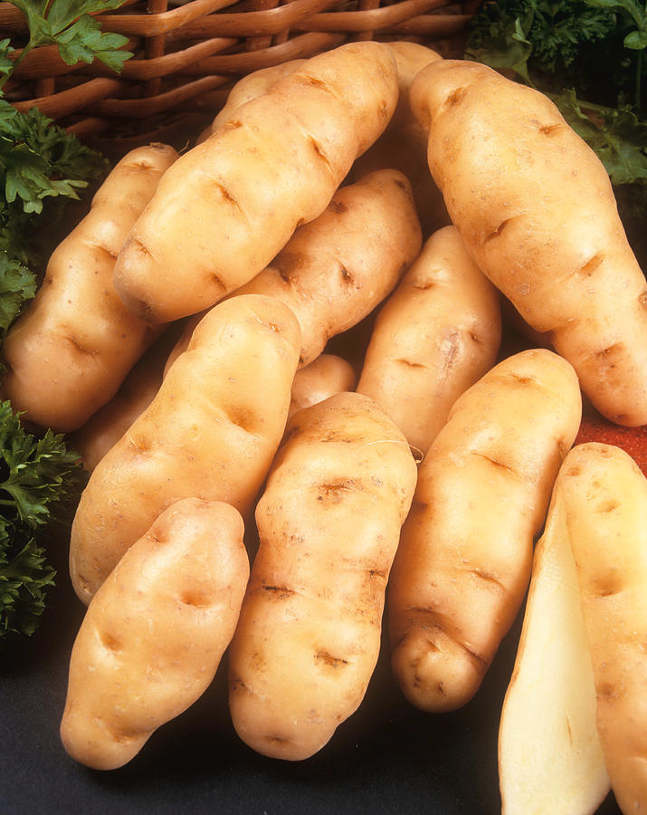 | White, long tubers, slightly knobbly, taste is slightly unusual being nutty, almost like a chestnut. Good boiled
Radish | 4 varieties:  Rudi, Sparkler, Minowase and Black Spanish. | 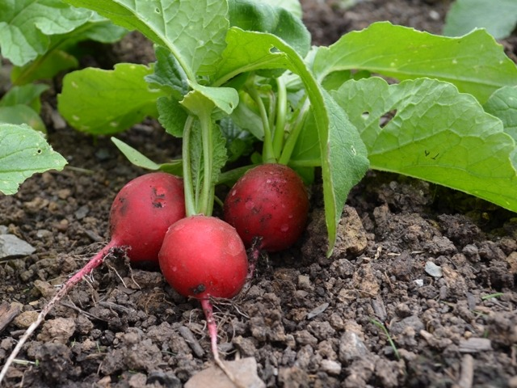 | Radish is usually eaten raw in salads. Cut off the root and the leaves at the base of the stem and wash. Use whole or cut as required.  Sliced radish is great in potato salad where the hot crispness combines well with the cool potato and mayonnaise.  They can also be carved into flowers for a beautiful garnish. There are you tube videos that will show you how to do this
Rhubarb | 4 varieties: | 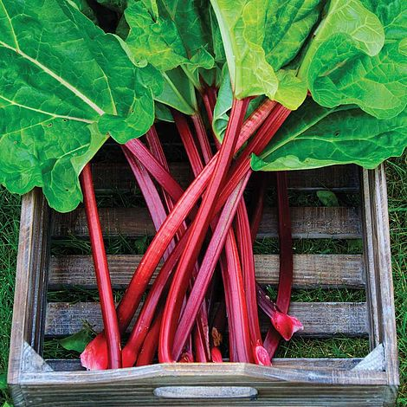 | Never eat the leaves of rhubarb, as they have toxic levels of oxalic acid and should not be eaten! Wash the stalks and cut off the leaves near the base. Check the rhubarb for any blemishes and use a vegetable peeler to remove them. Cut the stalk into chunks. Scatter with sugar, cover with foil and bake in a medium oven for about 15 minutes until soft or poach in a splash of water for about 8 mins
Rocket | Rucola | 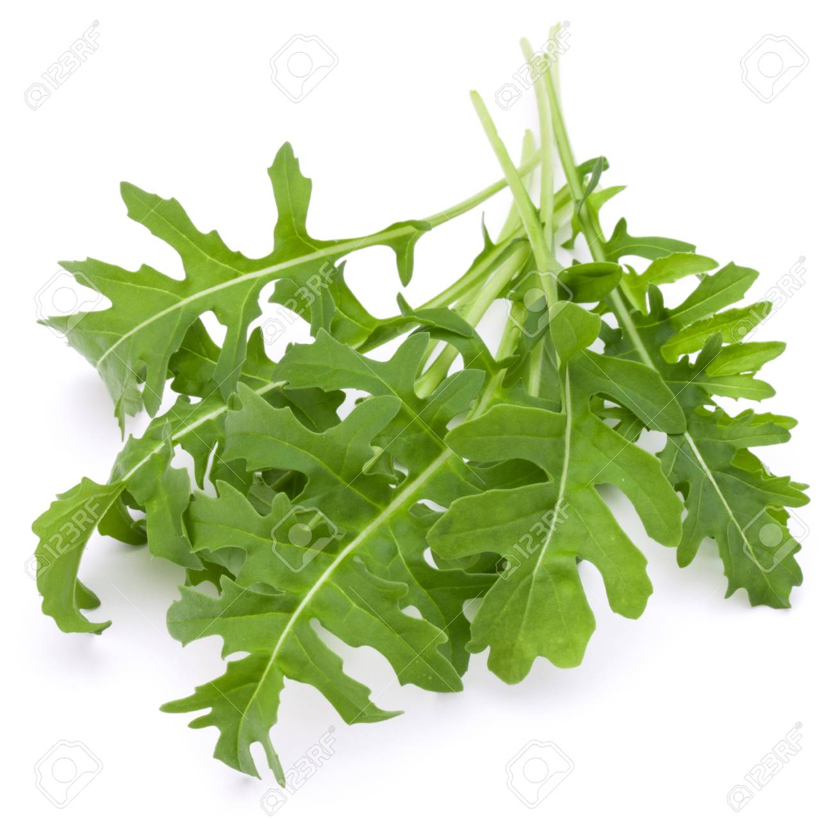 | Green leaf. Spicy and aromatic, but not too hot, put in salads
Spinach | Giant Winter | 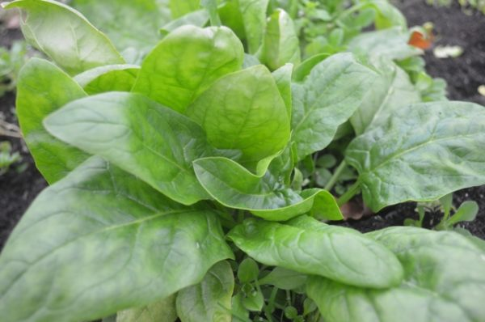 | Wash the leaves if necessary to remove any dirt and grit and use raw in smoothies.  To cook, shake off any excess water and heat in a saucepan without any additional water on a low heat for a few minutes only or steam.  Spinach is famously used as the base for Eggs Florentine and is also excellent in quiches, tarts, lasagne, spanakopita and cannelloni. One of our favourite ways to cook it is mixed with potato, spices and Lemon juice in Saag Aloo
Spinach | New Zealand | 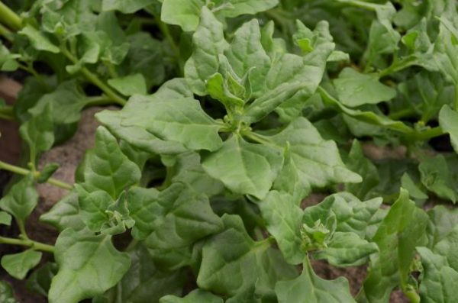 | As above
Squash | 6 varieties:  Jack be little, Turks Turban, Buttercup, Black Futsu, Blue Kuri and Sweet Dumpling. | 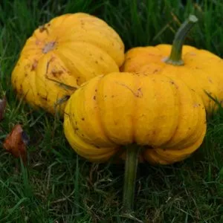 | Jack be Little – seen. Pumpkin puree is the main ingredient in pumpkin pie and can also be used in cakes. Pumpkin also makes a good soup. Make variations by adding different herbs, parsley and thyme. Or make it spicy by adding some chilli.
Swede or winter turnip | Friese Gele | 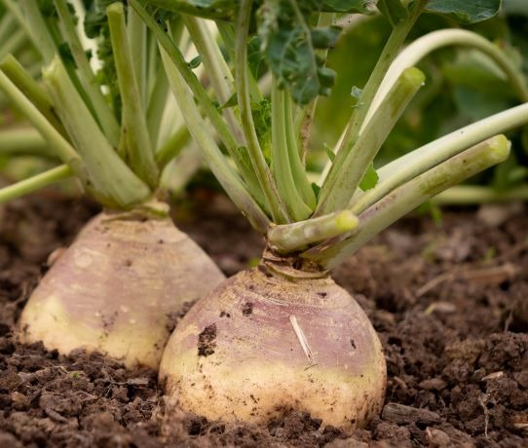 | Yellow flesh. Boiled and mashed, roast.  Peel and cut into chunks and boil until tender. Swede is often served mashed with butter and seasoning or mixed with other root vegetables. It is an essential ingredient in the authentic Cornish pasty but combines well with onion, potato and cheese in vegetarian pasties too.
Sweetcorn | Not grown this season.
Tomatoes | Not grown this season.
Turnip | Milan Purple Top | 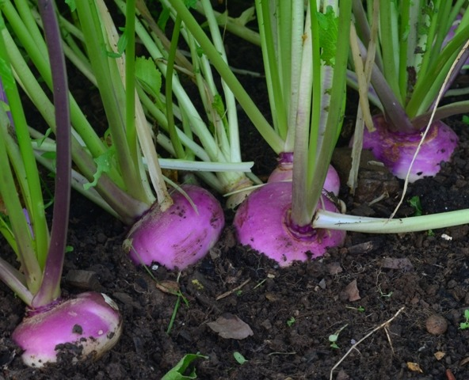 | Pull the roots and twist off the leaves. Rinse and cut the small root off.  Turnip skin is thin so it can be cooked whole or peel thinly if preferred. Turnips can be cut into strips or chunks and boiled, they can be mashed with butter and seasoning, or added to pies and stews. They can also be roasted in their skins.

Pictures from Tamar Organics and Seed Co-op + Skea potatoes. Globe artichoke not included.

